37.20: In the frame of one of the particles, and v are both 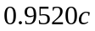 but with opposite sign.
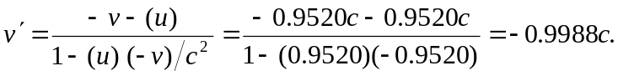
Thus, one particle moves at a speed 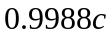 toward the other in the other particle’s frame.

